

Health Insurance
FTP Design Document

Version 03/20/2008
Employee Trust Funds
Applications Development Bureau
Division of Information Technology
801 West Badger Road
Madison, Wisconsin 53707

FTP Project Requirements 3
Background 3
Administration 4
Technical Specifications 4
Sending files 4
User Accounts 4
Encryption 4
Availability 4
Secure directories for files 5
Backup and Recovery 5
Naming Standards 5
Client Install Instructions 6

FTP Project Requirements
The Health Insurance Electronic Eligibility Data Transmission (EEDT) Processes need an FTP site to share data between ETF and approximately 16 Health Plans.

All files and exception reports will be generated in electronic format and transferred via secure FTP or comparable method between the health plans and ETF. Health plans will submit text files using an ANSI 834 file layout specified by ETF. ETF will setup the FTP site, user ids and passwords so each health plan has a secure path, and cannot see other health plan data.

Background
The Department of Employee Trust Funds has implemented a Secure File Transfer Protocol (SFTP) server for the purpose of transferring data files between ETF and its business partners and customers. IDs, passwords, and data are encrypted using 128-bit Secure Socket Layer (SSL) encryption.

The SFTP server is intended to be available 24 hours a day, 7 days a week, with the exception of the maintenance window on Sundays from 6:00am to 9:00am.

Data can be sent to or transferred from the SFTP server. A directory is assigned to each account and is only accessible to the account user and the system administrators.

Administration
Administration can be built around the needs of the business unit. This includes:

- Account Creation. This function will remain the responsibility of the ETF Computer Services Bureau (CSB). Generally, we ask for as much lead-time as possible for new accounts. In this instance, IDs should be fairly static. We request the following information when setting up an account:

- First and last name of the primary user
- Phone number of primary user
- Organization
- Client software license CD Number

- Media and Instructions Distribution. ETF Department of Employer Services (DES) will be responsible for distributing the client software media and installation/configuration instructions to the health plans. An install CD can be mailed, or a zipped executable file can be emailed to each health plan. CSB will duplicate the media and have it available for the DES. CSB will maintain installation/configuration instructions for use by DES.

- Technical Assistance. Partners and customers will use ETF’s helpdesk to obtain technical support. Business partners and customers should use their business unit contact for business related items and the helpdesk for technical assistance.

- File Copies to LAN. ETF has developed automated processes to move data files from the FTP server to the ETF server, thus minimizing any exposure to the Internet. The ETF server is protected on several fronts to minimize exposure.

Technical Specifications

Sending files
The Health Plan contact starts the WS_FTP client on their desktop. The user id and password are provided by the contact, and the connection to the ETF FTP file server is made. Data files will be “pushed” from the health plan to the ETF FTP file server.

User Accounts
User ids and passwords for each health plan will be created and maintained by the ETF CSB.

Encryption
IDs, passwords, and data are encrypted using 128-bit Secure Socket Layer (SSL) encryption. The health plans do not need to provide any encryption; it is handled by the SFTP process.

Availability
The SFTP server is intended to be available 24 hours a day, 7 days a week, with the exception of the maintenance window on Sundays from 6:00am to 9:00am.

Secure directories for files
Each health plan will have its own directory on the ETF FTP file server. This means that the directory can only be accessed by the specific health plan.

Backup and Recovery
Files that reside on the FTP file server are not backed up. Files that reside on the ETF file server are backed up nightly, and on a weekly and monthly rotation for 2 years.

Naming Standards
When creating files to send to ETF, the naming convention is:

Daily Transmissions:
Sender | Receiver | File Type | File Name
ETF | Health Plan | Daily EEDT 834 file | HIE834_ETF_99_YYYYMMDD.txt
Health Plan | ETF | Daily EEDT 997 Acknowledgement file | HIE997_99_ETF_YYYYMMDD.txt

Monthly Transmissions:
Sender | Receiver | File Type | File Name
Health Plan | ETF | Monthly Full File Compare (FFC) file | FFC834_99_ETF_YYYYMMDD.txt
Health Plan | ETF | Monthly Direct Pay Termination (DPT) spreadsheet | HIEDPT_99_ETF_YYYYMMDD.xls
ETF | Health Plan | FFC Database Activity Log file | FFCLOG_ETF_99.txt
ETF | Health Plan | FFC 834 Validation Results file | FFCRSLT_ETF_99.txt

“99” is the two digit carrier code assigned to the health plan by ETF. If a health plan has multiple carrier codes, ETF will determine the carrier code to be used.

Client Install Instructions

The purpose of this document is to describe the steps needed to install WS_FTP on windows 9x or 2000 operating systems, configure it to connect to ETF’s Secure FTP Server, and how to send files to ETF.

Secure FTP accounts and software can be requested through the ETF Helpdesk.

Phone: (608) 264-8333
e-mail: etf.helpdesk@etf.state.wi.us

Also, use the helpdesk as the primary contact for technical support.

Once an ID and temporary password are assigned, please follow the steps below to install, configure, and connect to the system and then change your temporary password.

WS_FTP Pro Minimum Requirements:

- Windows 95, 98, 2000, ME, or NT
- Microsoft IE 4.02 or higher.

I. Installation Method 1: from CD-ROM:

Note: Only one installation method needs to be followed. Either install from CD-ROM or from the compressed file. You will only need to install from the compressed file if you do not have a CD-ROM drive.

- Insert the FTP Client CD into the CD-ROM drive.

Note: If the “welcome” screen doesn’t appear, open explorer, navigate to your CD-ROM drive and double click the “Autorun.exe” program.

- Click the “Install WS_FTP Pro” icon.
- Click “Next”.
- Accept the default installation path or click the “browse” button to select an alternate location.
- Click “Next”
- Type your e-mail address in the “address:” field when prompted to enter an anonymous address or accept the default.
- Click “Next”.
- Click “Next” to accept the program folder name.
- Deselect (uncheck) “Install WS_FTP Pro Explorer Desktop Shortcut” and “Enable WS_FTP Pro Browser Integration”. Leave the “Install WS_FTP Pro Desktop Shortcut” if you wish to have the icon added to your desktop.
- Click “Next”.

The program will now copy the WS_FTP Pro program from the CD to the hard drive.

- Click “Finish” and accept the default “Yes, I want to restart my computer now”.

II. Installation Method 2: from Compressed File:

- Copy ETFWS_FTP.exe file to a hard drive.
- Run the file.
- Click “Unzip” to accept the default extraction location OR click “Browse” to choose an alternate location.
- Click “Close” on the “WinZip Self-Extractor – etfws_ftp.exe” window.
- Navigate to “C:\etf_wsftp\install” OR to the location you specified in step 3.
- Double click the “Setup.exe” icon.
- Follow steps 3 – 11 in the “Install from CD-ROM” section above.

III. FTP Client Configuration:

- Select WS_FTP Pro from Start menu|Programs|WS_FTP Pro or, if you created the desktop short cut, double click the WS_FTP Pro icon on your desktop if it is not already started.
- Select “New Site” from the File menu on the Connection window. See “Connection Menu” in Figure 1 below.
- Type “ETF-Secure FTP Site” in the “Site Profile Name” field.
- Type 165.189.30.95 in the “Host Name or IP Address” field.
- Click the “Next” button.
- Type your User ID assigned to you by ETF in the “User Id:” field.
- Click the “Finish” button.
- Click “Secure (SSL)” checkbox with the “ETF-Secure FTP Site” selected from the “configured sites” list. See “Secure(SSL) Checkbox” on Figure 1 below.
- Click the “Save” button.
- Click the “Connect” button to connect to ETF-Secure FTP Site”.

Note: For security reasons, it is strongly recommended NOT to save password information.

IV. Making a Connection:

- Select WS_FTP Pro from Start menu|Programs|WS_FTP Pro or, if you created the desktop shortcut, double click the WS_FTP Pro icon on your desktop if it is not already started.
- Select “ETF-Secure FTP Site” from the list of “configured sites”. See “Selected Site” in Figure 1 below.
- Click the “Connect” button.
- Type your password in the “Password on Remote Host:” field.
- Click the “Connect” button.

Note: if prompted to accept a “Non-Trusted Certificate” choose “Trust this certificate” and then click “OK”.

V. “FTP-ing” Files:

- Start WS_FTP Pro and make a connection as described above if it is not already started.
- Navigate to the location of the file you wish to upload to ETF using the “Local System” list of files and locations.
- Click the file you wish to upload. See “Files in Current Directory” in Figure 2.
- Click the “Upload” button to copy the file to the Secure FTP server. See figure 2.

Note: When the file is transferred, it will appear in the “Remote System” list.

Note: When finished transferring files, click the “Disconnect” button.
To close WS_FTP Pro, click the “Exit” button.

VI. Changing Passwords:

- Follow the instruction in the section “Making a Connection:”.
- Right click in the “Remote system” field. See “Current Remote System Directory” in Figure 2 below.
- Select “FTP Commands” from the menu that appears.
- Choose “SITE” from the menu that appears.
- Type “CPWD “ and then your new password in the “Enter a site command:” field.
- Check the “Log Field” to see that the command was successful.

Note: The text “200 CPWD successful” indicates a successful password change.

Note: The following figures are to show various fields and their location on particular windows. The actual values are not important.
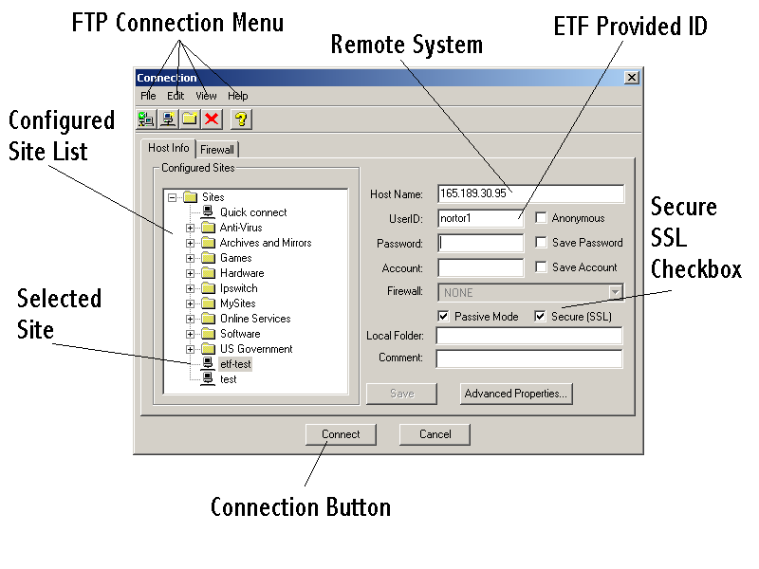
Figure 1 - Connection Window
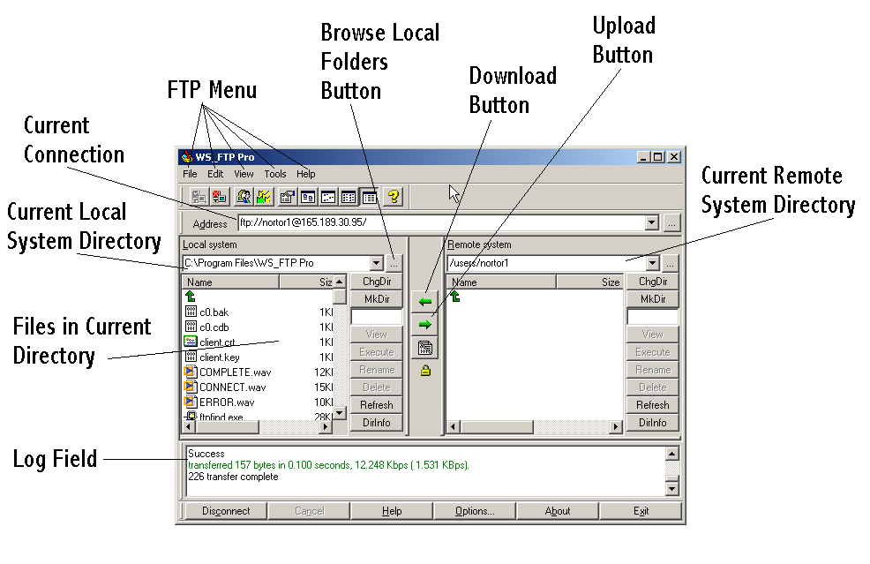
Figure 2 - FTP Window

